WESTERN PACIFIC UNIVERSITY
CMN224 / CMP224 Software Engineering — Week 9
Lab 6: Behavioural Diagrams for Your Client — Completed Worksheet
Item | Details
Client | School fee system (Bursar, Head teacher, district office) — replace if your Task 2 client differs
Linked to | Week 9 lecture — Behavioural UML and the 4+1 view model (ULO2, ULO4)
Contributes to | Task 4 Design & Modelling Deliverable (15%, due Week 11)
Tools | PlantUML source (appendix) and rendered diagrams

Part A — Use case diagram
Four actors (all roles), eight use cases and a drawn system boundary. The Parent is outside the system and only receives a receipt copy.
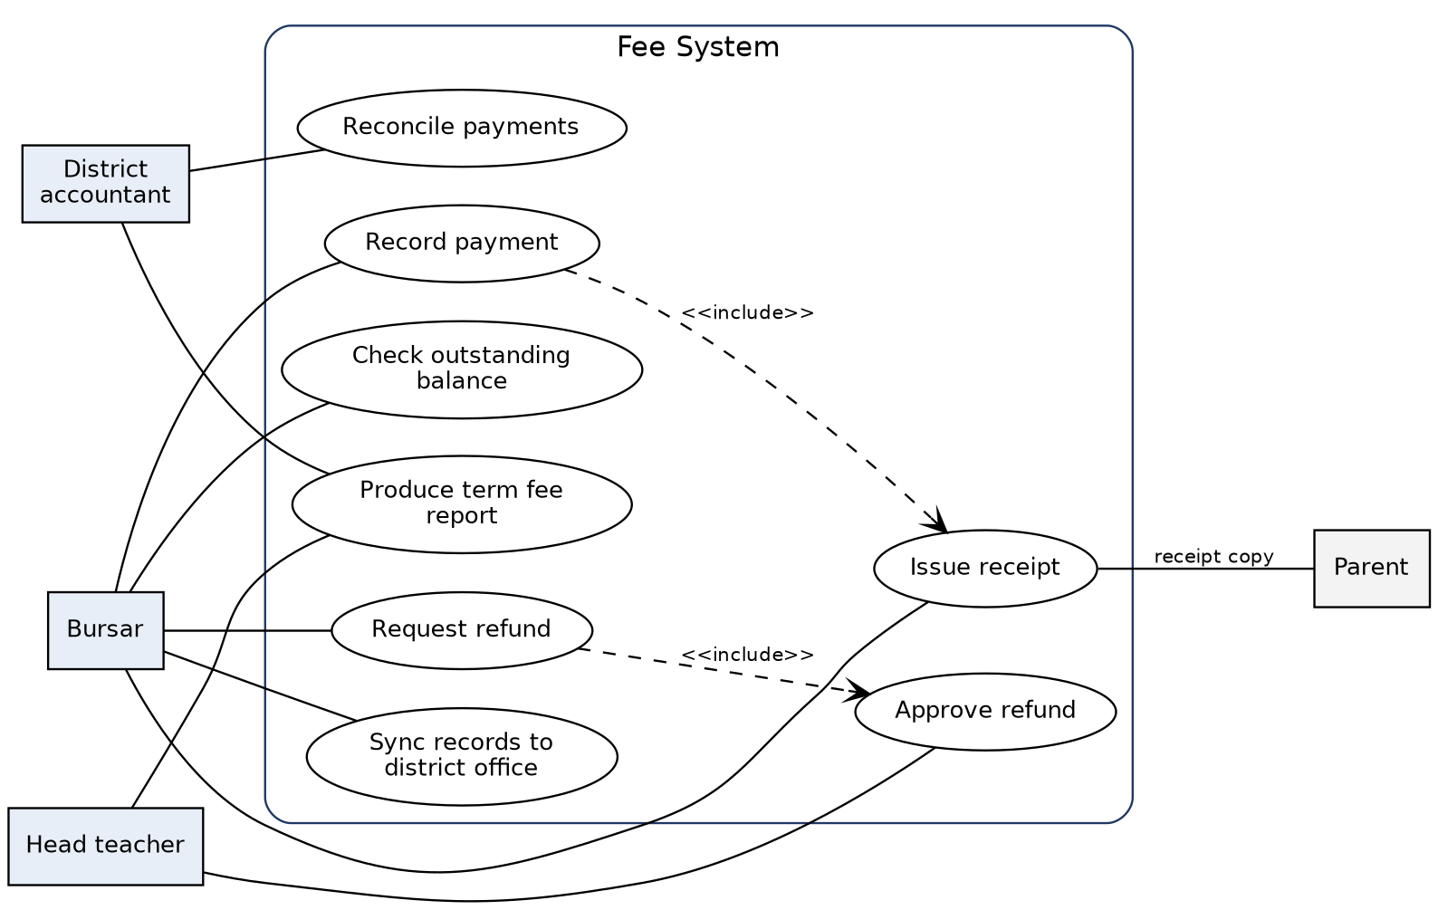
# | Check | Status
1 | Every actor is a ROLE, not a named person | Done
2 | Every use case is a goal (verb phrase the client would recognise) | Done
3 | The system boundary is drawn | Done
4 | Every use case traces to a user requirement in your SRS | To verify

Traceability (complete with your SRS IDs):
Use case | SRS requirement | Actor
Record payment | FR | Bursar
Issue receipt | FR | Bursar
Check outstanding balance | FR | Bursar
Request refund | FR | Bursar
Approve refund | FR | Head teacher
Reconcile payments | FR | District accountant
Produce term fee report | FR | Head teacher, District accountant
Sync records to district office | FR | Bursar

Part B — Class diagram
Six classes with named associations and multiplicity at both ends.
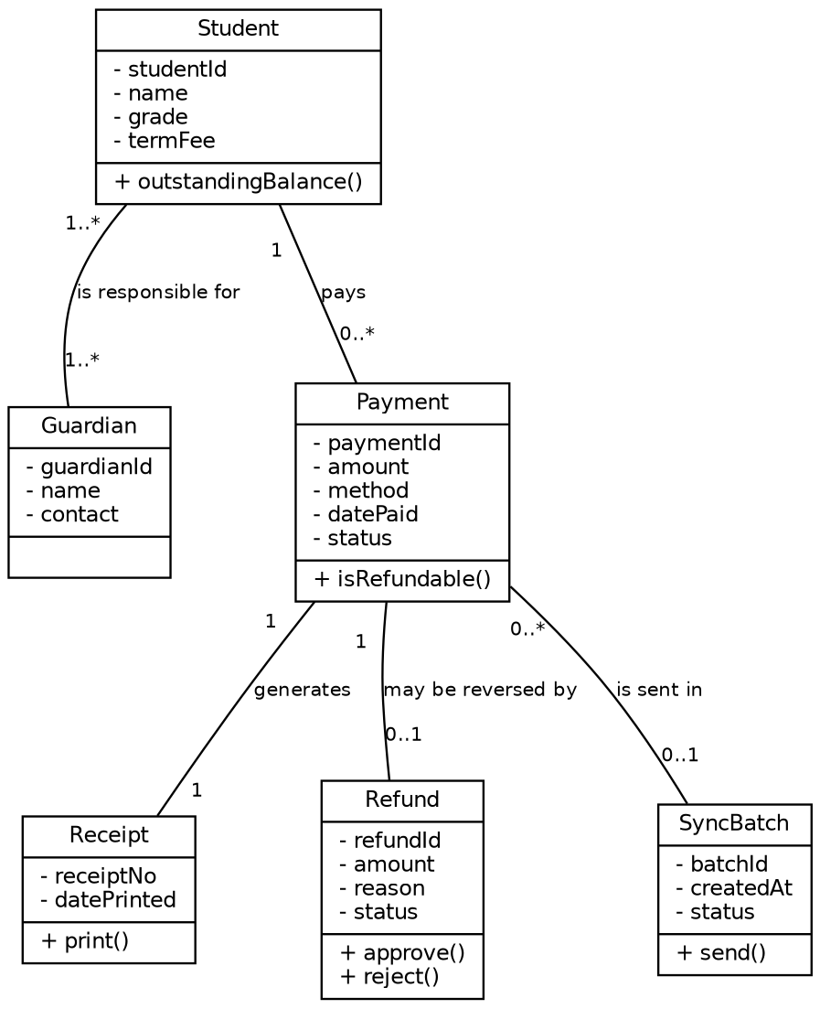
Business rules encoded by multiplicity:
- Every payment generates exactly one receipt (Payment 1 — 1 Receipt).
- A payment can be reversed by at most one refund (Payment 1 — 0..1 Refund).
- A payment is in at most one sync batch, which keeps import duplicate-safe (Payment 0..* — 0..1 SyncBatch).
# | Check | Status
1 | Every association is NAMED | Done
2 | Multiplicity is shown at both ends | Done
3 | At least one multiplicity encodes a real Week 2 business rule | Done
4 | No attribute exists that your SRS never mentions | To verify

Part C — State diagram (Payment lifecycle)
A payment moves from Recorded to Receipted to Reconciled, and can then be refunded or closed with the term.
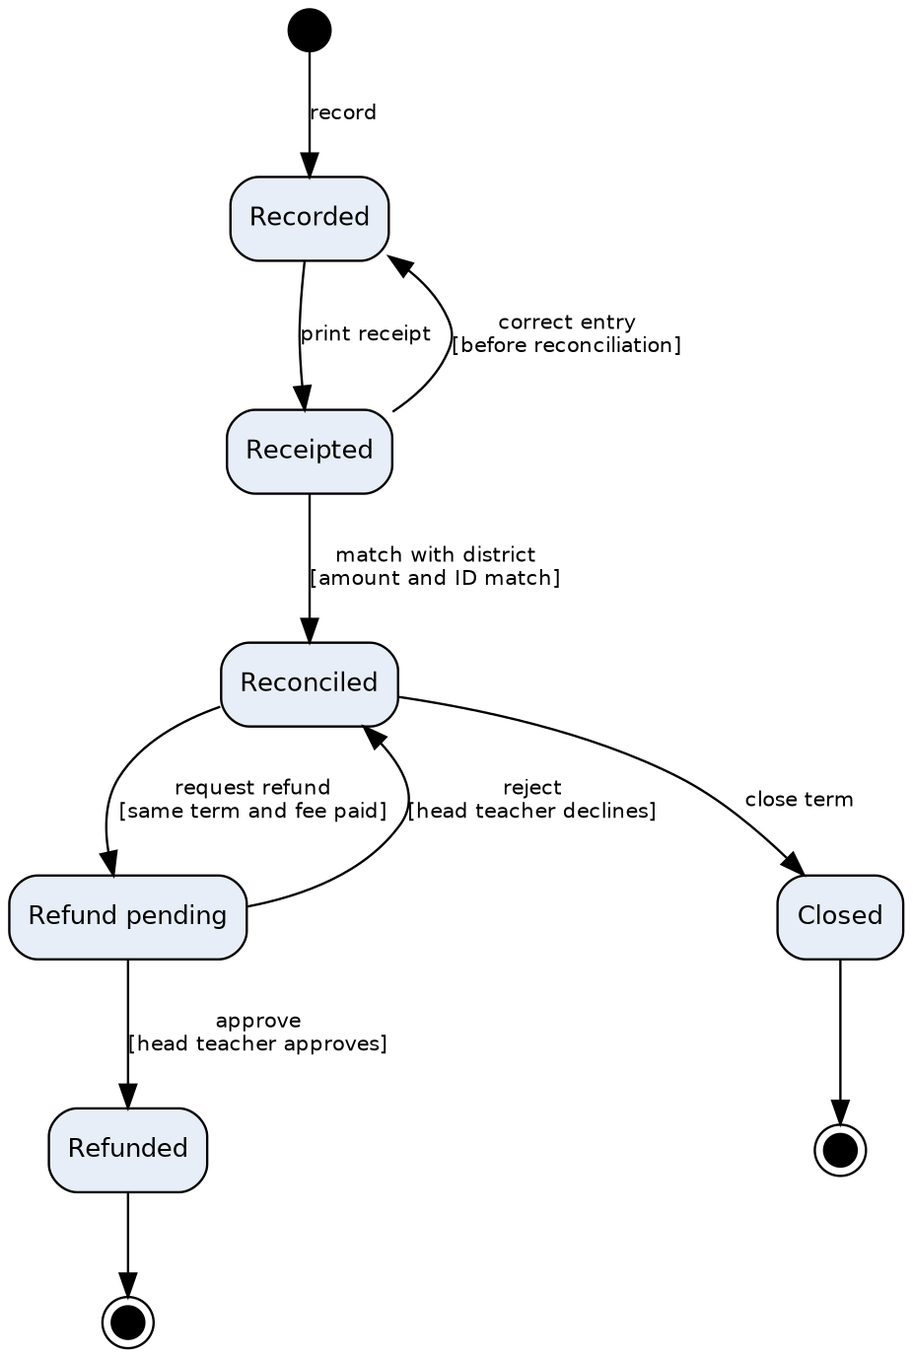
# | Check | Status
1 | Every state is a CONDITION, not an action | Done
2 | Every transition names its trigger | Done
3 | At least one guard encodes a business rule (head teacher approves; same term and fee paid) | Done
4 | Start state and at least one end state | Done

Part D — Activity diagram with swimlanes
Workflow: record a payment at the school and sync it to the district office. The decision node handles the case where the network or power is unavailable.
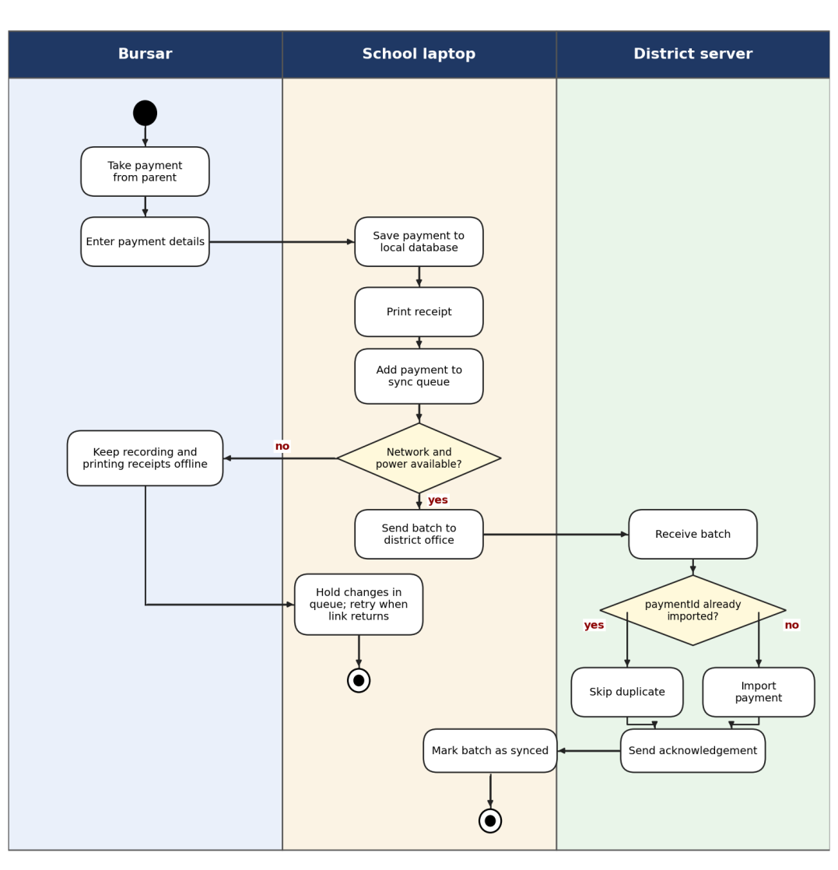
# | Check | Status
1 | Swimlanes match devices/roles in my deployment diagram | To verify
2 | There is a decision node for the offline case | Done
3 | Workflow shows what staff can still do while the link is down | Done
4 | Duplicate-safe handling appears where data is imported | Done

AI use declaration
PlantUML drafts were generated with Claude (Anthropic) from the lab starters. I validated every diagram against my own SRS using the five lecture checks, paying particular attention to the offline branch and the refund approval chain.

